Covalent Molecular Compounds

Covalent bonds form between non-metal atoms. Each bond consists of a shared pair of electrons (localised between the two bonded atoms). Covalent bonds are is very strong. Covalent molecular compounds generally contain only a few atoms held together by strong covalent bonds – forming a small group of atoms. No covalent bonds extend beyond the molecule – this means that each molecule is not held very strongly to other covalent molecules. Covalent molecular compounds do not form a lattice structure.
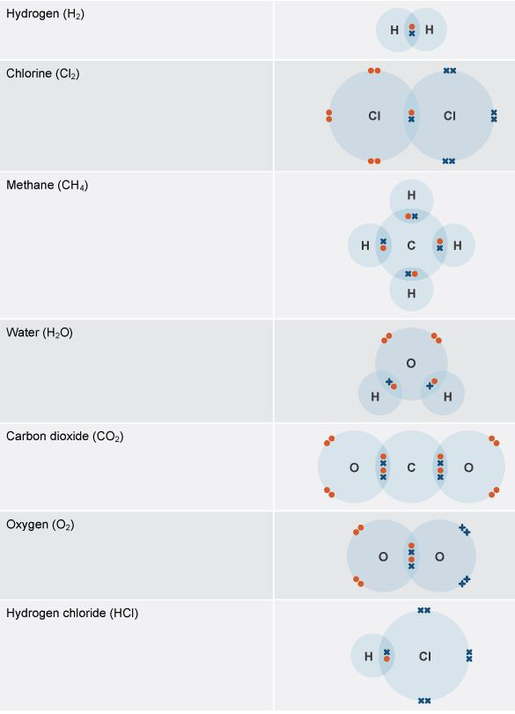
Simple molecules
An example shown below is carbon dioxide (CO₂), whose molecules contain one atom of carbon bonded with two atoms of oxygen. Other examples – also shown as Lewis Diagrams (or electron dot diagrams) are shown in the table on the right

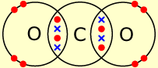
A molecule of carbon dioxide

Hydrogen, ammonia, methane and water are also examples of simple molecules with covalent bonds. All these substances have very strong bonds between the atoms, but much weaker forces holding the molecules together. When one of these substances melts or boils, it is these weak 'intermolecular forces' that break, not the strong covalent bonds. This means that simple molecular substances are gases, liquids or solids with low melting points and low boiling points.
Weak intermolecular forces between water molecules break during boiling or melting.

Properties of simple molecular substances
- Low melting and boiling points
This is because the weak intermolecular forces break down easily.
- Non-conductive
Substances with a simple molecular structure do not conduct electricity. This is because they do not have any free electrons and do not have an overall electric charge.
The Shape of Covalent Molecules

Valence-Shell Electron-Pair Repulsion - VSEPR Theory
The shape of a covalent molecule is determined by the number of bonds around the central atom(s) in the molecule. Each central atom will have 4 pairs of electrons in its valence shell. Some (or possibly all) of these pairs will be forming a bond with another atom. Repulsion between these four pairs of electrons causes them to be a far apart as possible - they form a tetrahedral shape around the central atom. If all four pairs are bonding pairs the molecule will assume a tetrahedral shape with the central atom in the middle. If one or more of the pairs is not a bonding pair, the shape will still be based on a tetrahedral, but with parts of the tetrahedron missing (in the missing part is a non-bonding pair of electrons.

VSEPR theory states that because electron pairs repel, molecules adjust their shapes so that the valence electrons are as far apart as possible.

When determining the shapes of the molecules using VSEPR theory:
- Draw a Lewis diagram of the molecule with the atom which forms the most bonds in the centre.
- Look at the valence shell of the centre atom – there are usually (except for boron or hydrogen) 4 pairs of electrons in this valence shell.
- Valence pairs of electrons will repel each other. To be as far away from each other as possible a tetrahedral shape will be formed by the 4 pairs of electrons around the central atom.
- Non-bonding pairs of electrons are important for two reasons. They do not appear in the shape of the molecule AND being closer to the central atom (as they are not shared) they strongly repel the bonding pairs of electrons.
- Double or Triple bonds change the arrangement of the electrons around the central atom. A double and two single bonds arranges in a triangle not a tetrahedral shape.
- Common shapes: tetrahedral, pyramidal, bent (all based on a tetrahedral shape); triangular planar, linear.

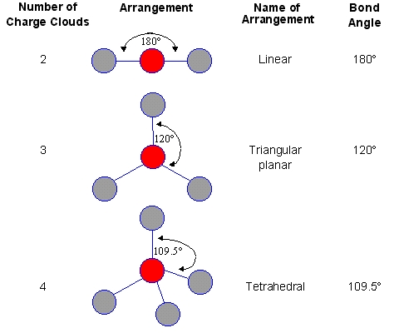
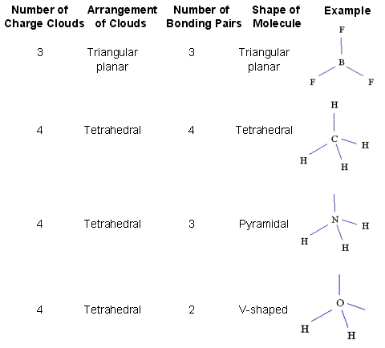

Covalent Network Structures
Giant covalent structures contain very many non-metal atoms, each joined to adjacent atoms by covalent bonds. The atoms are usually arranged into giant regular lattices - a structure which is extremely strong because of the many bonds involved. The graphic shows the molecular structure of diamond and graphite - two allotropes of carbon - and of silica (silicon dioxide).
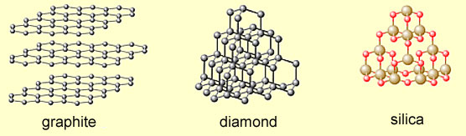
Properties of giant covalent structures
- Very high melting points
Substances with giant covalent structures have very high melting points because there are very many strong covalent bonds that must be broken. Graphite, for example, has a melting point of more than
3,600°C.
- Variable conductivity
Diamond does not conduct electricity. Graphite contains free electrons, and so does conduct electricity. Silicon is semi-conductive - ie, midway between non-conductive and conductive.
Examples:
Graphite
Graphite is a form of carbon in which the carbon atoms form layers. These layers can slide over each other, so graphite is much softer than diamond and is used in pencils and as a lubricant. Each carbon atom in a layer is joined to only three other carbon atoms. Graphite conducts electricity.

Diamond
Diamond is another form of carbon in which each carbon atom is joined to four other carbon atoms, forming a giant covalent structure. As a result, diamond is very hard and has a high melting point. Diamond does not conduct electricity.

Silica
Silica, which is found in sand, has a similar structure to diamond. It's also hard and has a high melting point, but it contains silicon and oxygen atoms instead of carbon atoms.
The fact that it is a semi-conductor makes it immensely useful in the electronics industry: most transistors are made of silica.

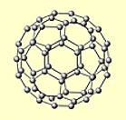
Bucky Balls
Bucky Ball is yet another allotrope of carbon. It is actually not a giant covalent structure but a giant molecule, in which the carbon atoms form pentagons and hexagons, just as in a football. It is used in lubricants.

